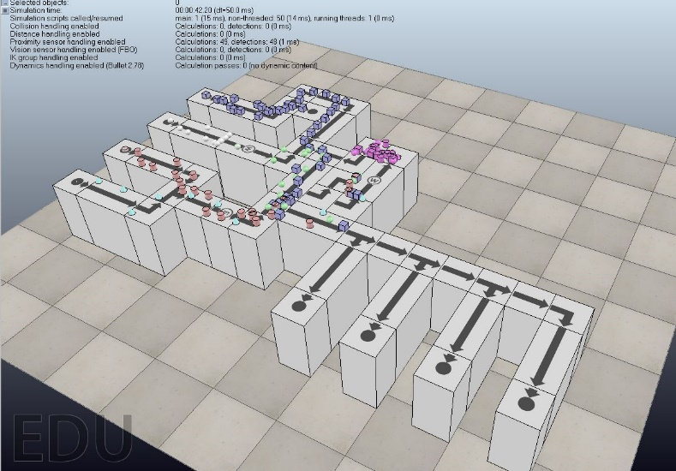Scene 1

In this scene the certain components are moving to certain area. It seems like they are moving to the designated area based on the color of the components. In manufacturing today, they use this kind of scene to move and categorize packages.

Scene 2

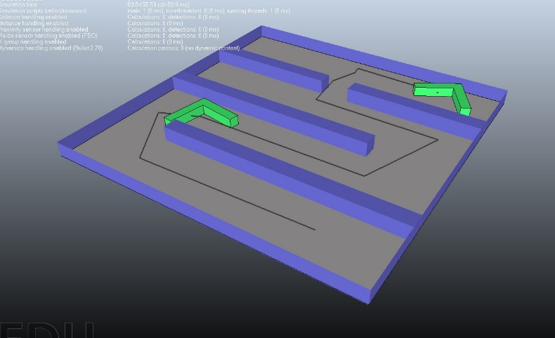

In this scene it seems like the layout has a pathway that tells the green component where to go. This is similar to Scene 1. In a way, this would similar to moving and categorizing packages. Many warehouses today, such as Amazon, can use this to move inventory and such.

Scene 3

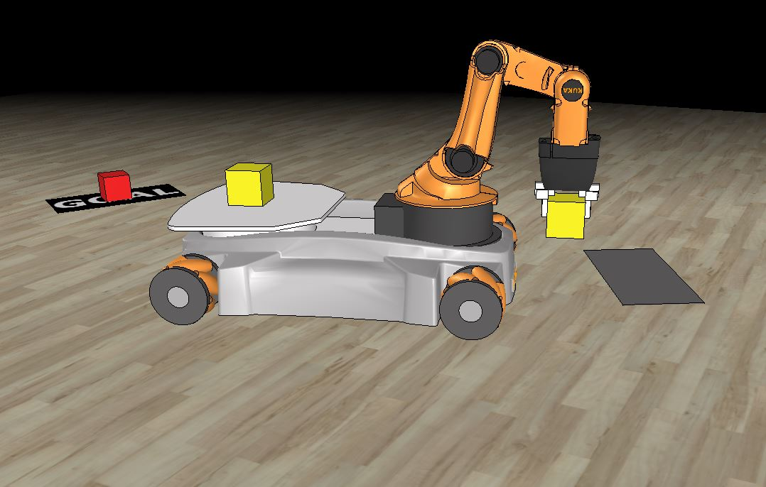

In this scene the robot is picking up the blocks and moving it to its specified spot. I believe it is a pick and place robot. In manufacturing today, pick and place robots are used to move components. They are use to move components because they are more accurate and precise.